SIMATS ENGINEERING
Saveetha Institute of Medical and Technical Sciences
Chennai – 602105

Assignment Report
Name:C .Rahul pramodh
Register number:192373039
Course Code & Name: CSA1418 – Compiler Design
Project Title: Lexical Analysis and Syntax Checking of Arithmetic Expressions for an E-Commerce Order Billing Program Using CFG-Based Parsing

1. Problem Statement
An e-commerce order billing system performs several arithmetic operations such as calculating the total price, applying discounts, and adding taxes. These calculations are represented using arithmetic expressions.

The proposed system aims to develop a simple compiler front-end module that accepts an arithmetic expression used in an e-commerce billing program and performs lexical analysis and syntax checking.

Consider the expression:
totalBill = (price * quantity) - discount + (tax * quantity)

The system should identify and classify tokens such as identifiers, operators, delimiters, and constants. After lexical analysis, syntax analysis is performed using a Context-Free Grammar (CFG) to verify whether the expression follows the specified grammar.

The system should also detect errors such as invalid identifiers, mismatched parentheses, and missing operators. Finally, the parser should construct or display the parse tree for a valid expression.

2. Objective
• To develop a simple compiler front-end for arithmetic billing expressions.
• To perform lexical analysis and identify different types of tokens.
• To classify keywords, identifiers, operators, delimiters, and constants.
• To design a Context-Free Grammar for arithmetic expressions.
• To perform syntax analysis using the designed CFG.
• To validate whether a given billing expression is syntactically correct.
• To construct a parse tree for valid arithmetic expressions.
• To detect invalid identifiers and other lexical errors.
• To detect mismatched parentheses.
• To detect missing operators between operands.
• To provide meaningful error messages for invalid expressions.
• To demonstrate the practical application of lexical and syntax analysis.

3. Requirements and Environment Used
3.1 Hardware Requirements
• Computer or laptop
• Minimum 4 GB RAM
• Dual-core processor or higher
• Minimum 500 MB free storage
• Keyboard and mouse

3.2 Software Requirements
• Operating System: Windows / Linux / macOS
• Programming Language: Python
• Code Editor: Visual Studio Code / PyCharm
• Python Version: Python 3.x
• Parsing Method: Context-Free Grammar based parsing

3.3 Environment Used
• Development Environment: Visual Studio Code
• Programming Language: Python
• Lexer: Custom lexical analyzer
• Parser: Recursive descent parser
• Grammar: Context-Free Grammar
• Testing: Terminal/Command Prompt

4. Design / Proposed Solution
The proposed system consists of two major phases: Lexical Analysis and Syntax Analysis.

Phase 1 – Lexical Analysis
The lexical analyzer reads the input expression character by character and groups the characters into meaningful tokens.

Token types include:
• Identifier – totalBill, price, quantity, discount, tax
• Operator – +, -, *, /, =
• Delimiter – (, )
• Constant – 10, 25, 100
• Keyword – if, else, while, etc.

For the expression totalBill = (price * quantity) - discount + (tax * quantity), the tokens include:
totalBill, =, (, price, *, quantity, ), -, discount, +, (, tax, *, quantity, )

Phase 2 – Syntax Analysis
The parser checks whether the tokens follow the Context-Free Grammar.

Grammar:
Assignment → ID = Expression
Expression → Term Expression'
Expression' → + Term Expression' | - Term Expression' | ε
Term → Factor Term'
Term' → * Factor Term' | / Factor Term' | ε
Factor → ( Expression ) | ID | NUM

This grammar maintains the precedence: Parentheses → Multiplication/Division → Addition/Subtraction.

5. Algorithm / Pseudocode
Algorithm for Lexical Analyzer
1. Start the program.
2. Read the arithmetic billing expression.
3. Scan the expression from left to right.
4. Ignore white spaces.
5. Identify identifiers, constants, operators, and delimiters.
6. Report invalid characters as lexical errors.
7. Display identified tokens.
8. Pass tokens to the syntax analyzer.
9. Stop.

Algorithm for Syntax Analyzer
1. Start with the token list.
2. Check whether the first token is a valid identifier.
3. Check whether the assignment operator = is present.
4. Parse the expression according to the CFG.
5. Check factors, terms, and expressions.
6. Verify matching parentheses.
7. Detect missing operators or operands.
8. If all grammar rules are satisfied, accept the expression.
9. Otherwise, report the syntax error.
10. Display the parsing result.
11. Stop.

6. Implementation / Source Code
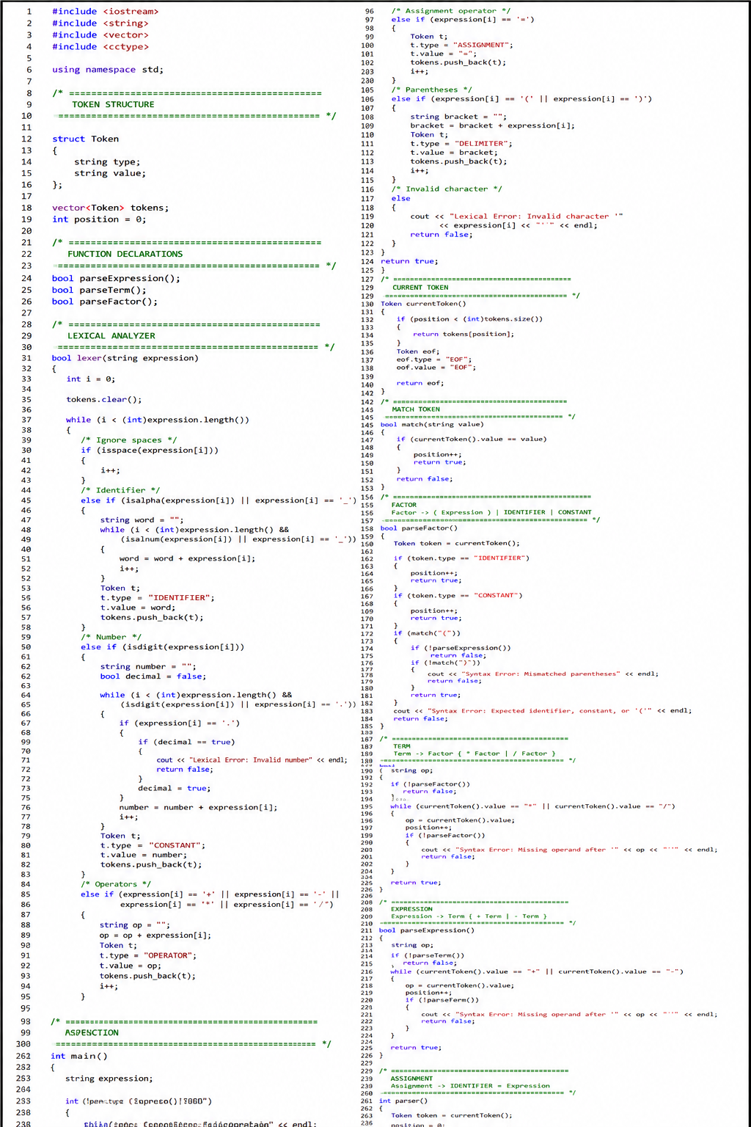

7. Test Cases and Expected / Actual Results
1. totalBill = (price * quantity) - discount + (tax * quantity) — Valid
2. totalBill = price * quantity — Valid
3. totalBill = (price * quantity) — Valid
4. totalBill = price + discount — Valid
5. totalBill = (price * quantity — Mismatched parentheses
6. totalBill = price quantity — Missing operator
7. totalBill = price + — Missing operand
8. totalBill = price @ quantity — Invalid character
9. 1totalBill = price * quantity — Invalid identifier
10. totalBill = (price + quantity) * tax — Valid

8. Output
Sample Valid Input:
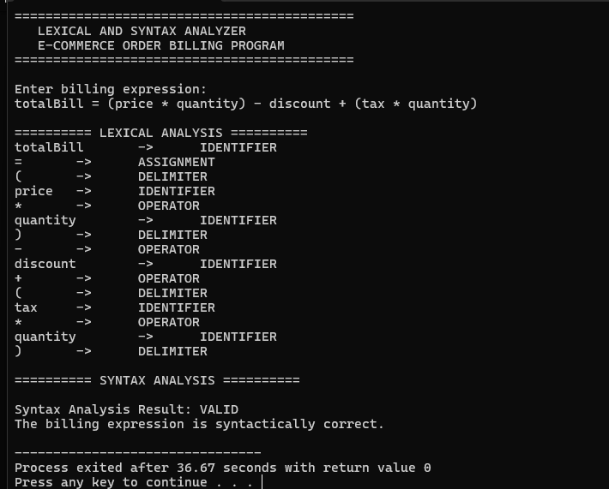

9. Analysis and Discussion
The proposed compiler front-end uses lexical analysis and syntax analysis to validate arithmetic expressions used in e-commerce billing. The lexical analyzer separates the input into meaningful tokens, while the syntax analyzer verifies whether those tokens follow the Context-Free Grammar.

The grammar correctly represents arithmetic precedence. Multiplication and division are handled at the Term level, while addition and subtraction are handled at the Expression level. Parentheses are handled through the Factor rule.

The system detects invalid characters, invalid identifiers, mismatched parentheses, and missing operands/operators.

Advantages:
• Simple and easy to understand.
• Separates lexical and syntax analysis.
• Uses CFG-based parsing.
• Detects common expression errors.
• Supports arithmetic operators.
• Handles nested parentheses.

Limitations:
• Supports a limited set of operators.
• Does not perform semantic analysis.
• Does not calculate the actual billing amount.
• Advanced compiler features are not included.

10. Conclusion
The Lexical Analysis and Syntax Checking of Arithmetic Expressions for an E-Commerce Order Billing Program was successfully designed as a compiler front-end application.

The system performs lexical analysis by identifying identifiers, operators, delimiters, and constants. Syntax analysis is then performed using a Context-Free Grammar to determine whether the billing expression is syntactically valid.

The system handles valid expressions and detects errors such as invalid characters, mismatched parentheses, missing operators, and invalid identifiers.

The project provides a practical understanding of lexical analysis, CFG design, parsing, error detection, and syntax validation.

11. Individual Contribution of Group Members
Member 1 – Prepared the problem statement, objectives, and requirements.
Member 2 – Designed the CFG and developed the lexical analyzer.
Member 3 – Developed the syntax parser and implemented error handling.
Member 4 – Prepared test cases, output, analysis, and final documentation.

12. References
1. Alfred V. Aho, Monica S. Lam, Ravi Sethi, and Jeffrey D. Ullman, Compilers: Principles, Techniques, and Tools, Pearson.
2. Charles N. Fischer and Ron K. Cytron, Crafting a Compiler, Pearson.
3. Kenneth C. Louden, Compiler Construction: Principles and Practice, Cengage Learning.
4. Dick Grune et al., Modern Compiler Design, Springer.
5. GeeksforGeeks, Compiler Design – Lexical Analysis and Syntax Analysis.
6. TutorialsPoint, Compiler Design – Lexical Analysis and Parsing.

